**­**

|  |  |
| --- | --- |
| **Total Marks:** |  |
| **Obtained Marks:** |  |

**Operating System Lab**

**Class Task**

**Last date of Submission: Mar 28, 2025**

**Submitted To: Sir Jawad Naseer**

**_______________________________________________________________________________________________________________________________________________________________________________________________________________________________________**

**Student Name: Ubaid Bin Waris**

**_______________________________________________________________________________________________________________________________________________________________________________________________________________________________________**

**Reg Number: 2212416**

**_______________________________________________________________________________________________________________________________________________________________________________________________________________________________________**

**Actvity 1:**

**Code:**

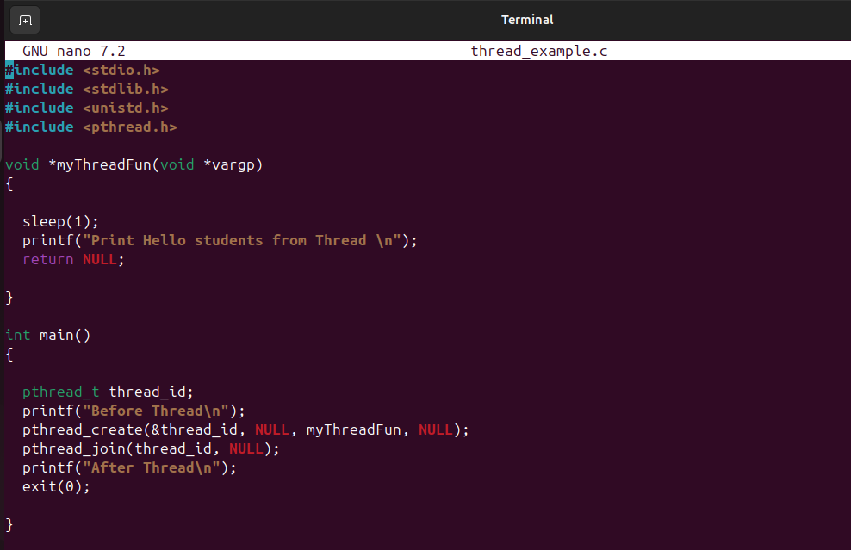

**OUTPUT:**

